Data Set: Warehouse and Retail Sales
https://catalog.data.gov/dataset/warehouse-and-retail-sales

Problem Statement:
This project analyzes warehouse and retail sales data to determine whether wine generates higher retail sales than other item types in the dataset. The data contains item types and retail sales values, which can be used to compare the total retail sales between different categories.

Hypothesis:
Wine will have a higher total amount of retail sales than the other item types found in the dataset.

How it will be tested:
The dataset will be separated by item type, and the retail sales values for each category will be summed. Using command-line tools such as awk, the total retail sales for each item type will be calculated and compared. The results will then be analyzed to determine whether wine has the highest total retail sales among the item categories.

Screenshots:
Loads dataset from CSV
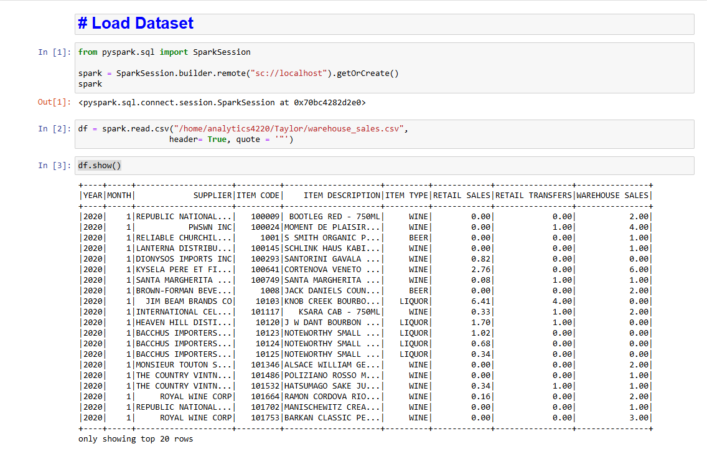

Changes all warehouse sales, retail sales, and retail transfers columns to float from string

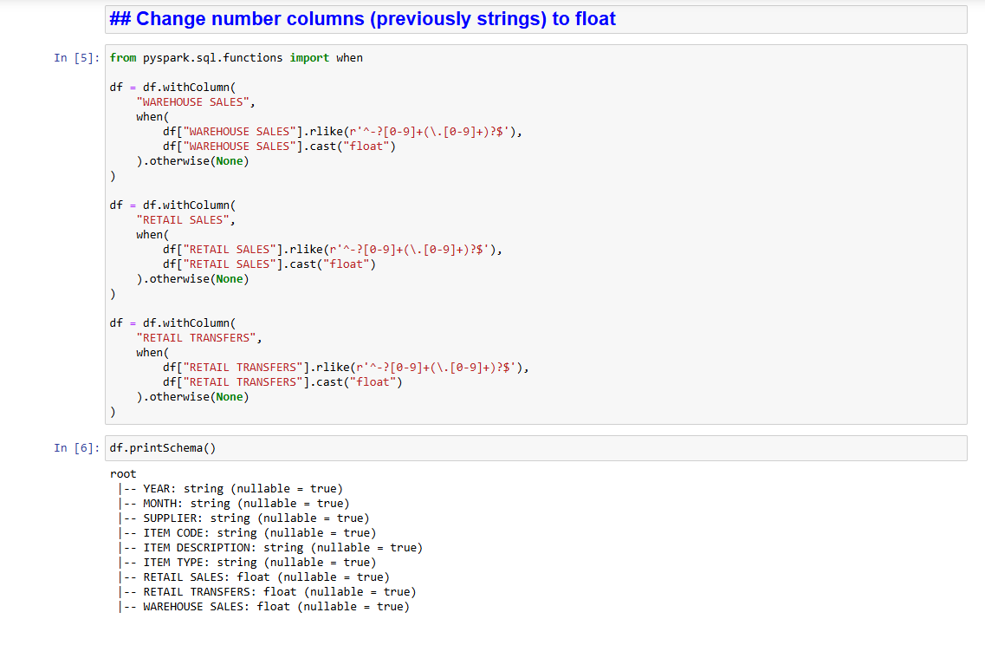

Shows first 20 rows(used all rows in dataset) and found the total count of each item type

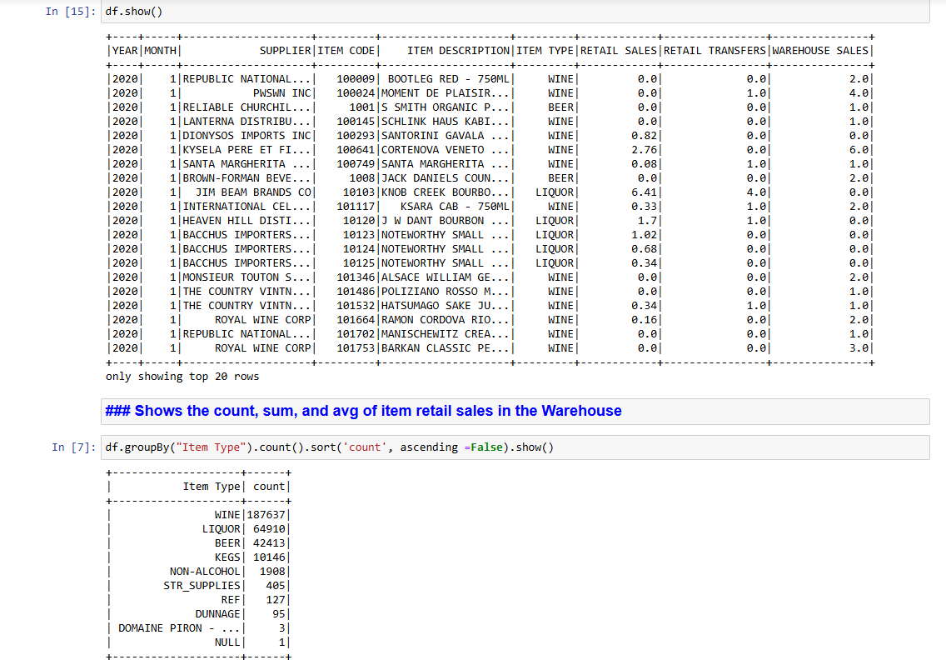
Show the total retail sales and the average retail sale per item type
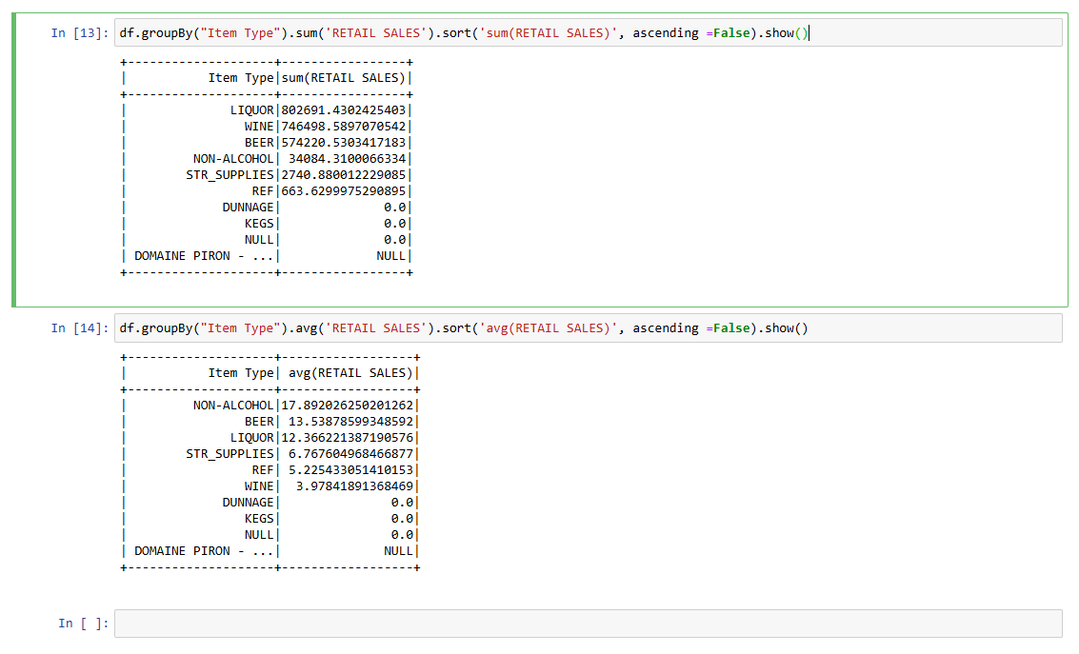

Conclusions:
Similar to my earlier conclusions from before liquor had the highest overall retail sale which was different from my initial hypothesis.This again suggests liquor is the overall more popular item from the warehouse which could suggest that the warehouse caters to establishments that order liquor order wine (possibly a primarily liquor shipper). Though wine still makes up a marginable amount of both retail sales and overall number of listed records in the dataset (with it being the highest overall) suggesting that the warehouse still ships a considerable amount of wine. Finally, based on the average of each item type, non alcohol actually is the highest compared to the amount of records listed which suggests that when a shipment of non alcoholic drinks are done the sales are overall high (despite overall less shipments compared to other item types).

